**Robstown Young Futures**

Community Gym 2025 Advertising

Robstown Young Futures is in action to restore the community complex located at 401 W. Ligustrum Blvd., offering recreation, sports, after-school programming, family events, and more.

Secure your sponsorship today and show your support to the community of Robstown!

$1,000 ____ 6’ x 3’ Company Banner with Logo and Information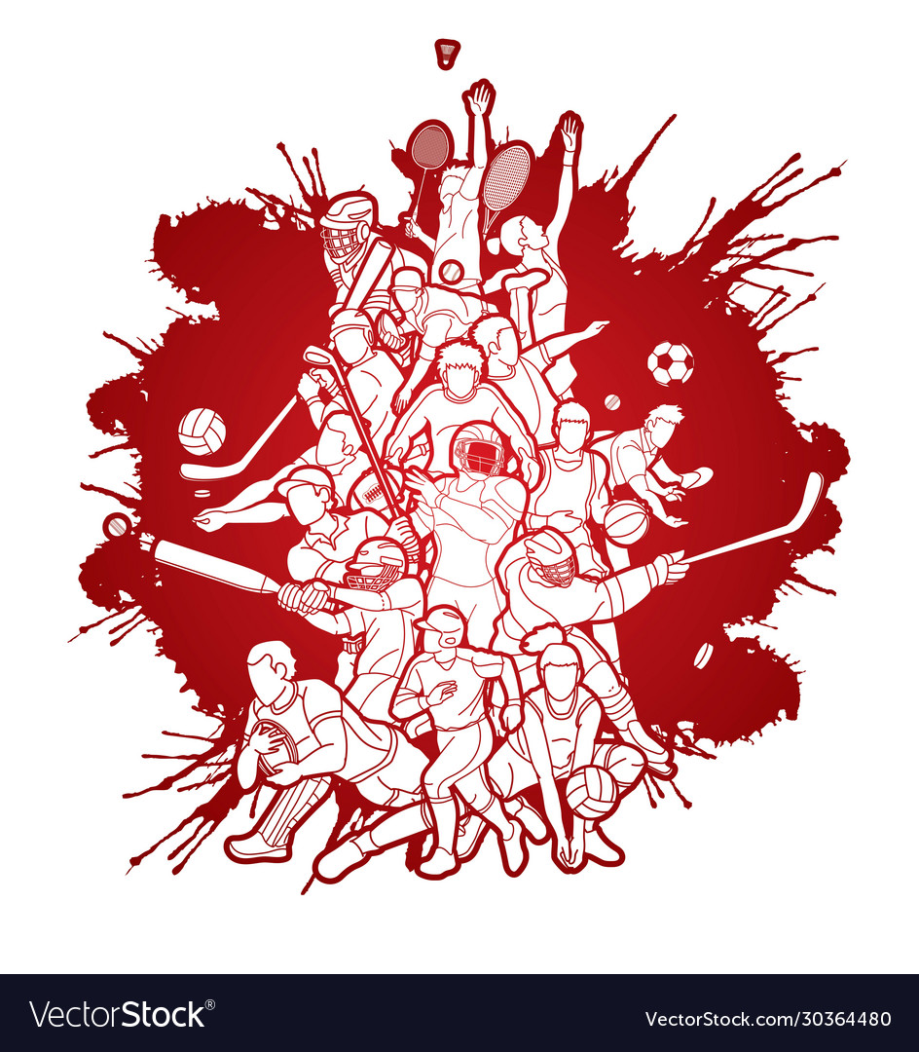

$500 ____ Community Supporters Plaque, Company Name Included

Company Name: ______________________________________________

Contact: _____________________________________________________

Phone: ______________________________________________________

Email: _______________________________________________________

Address: _____________________________________________________



____ Pay in full by __ check __ online payment

____ Pay in (4) equal, monthly installments

____ Renew annually

Authorized by: __________________________________________

Signature: _____________________________________________ Date: _________________

*Advertising agreement will be in place for a term of one year, 12-months beginning at the time of display and eligible for renewal. All proceeds are tax-deductible and a receipt will be provided.*

Internal Use

Logo Graphic Received:

Payment Received: